**Course Handouts**

**English for Specific purposes**

***Branch : English Language***

***Speciality: Language and Communication***

***Module : ESP***

**Level*: Master 1***

***Presented by:***

***Dr. Abdallah BOUGUENOUS***

***Academic year: 2021 /2022***

**Lesson 1 English for Specific Purposes (Review)**

1. **Lesson Description**

Thefirst lesson for Master 1 students is a summary of 3rd year main lessons that revolve around ESP definitions, principles, theories and practical implications of ESP in the teaching field.

1. **Lesson Objectives**

The main objective of the present lesson is to consolidate what has been already learnt about ESP.

1. **Lesson Content**

**3.1- Definitions of ESP**

Although ESP, as a discipline, has existed for more than decades, there still has been a considerable debate about its exact meaning. To grasp the real meaning of ESP, one should consider many aspects such as: the characteristics of ESP, the learners’ age and the time of learning, the purposes and the objectives of the courses, the materials and the methodology.

**For Hutchinson and Waters (1987)** ESP is an approach to language teaching based on learner’s needs and reasons for learning a language , it is not a product but “an approach to language teaching in which all decisions as to content and method are based on the learner’s reason for learning”.

With regard to **John Munby (1978)** “ESP courses are those where the syllabus and materials are determined in all essentials by the prior analysis of the communication needs of the learner.

**Mackay and Mountford (1978)** regard English for Specific Purposes as:

A restricted repertoire of words and expressions selected from the whole language because that restricted repertoire covers every requirement within a well defined context, task or vocation.

**Dudley-Evans and St. John (1998)** have modified Strevens’(1988) definition and define ESP in terms of ‘absolute’ and ‘variable’ characteristics.

**3.3- Characteristics of ESP**

**A)-**Absolute Characteristics  
**1.** ESP is defined to meet specific needs of the learners   
**2.** ESP makes use of underlying methodology and activities of the discipline it serves   
**3**. ESP is centered on the language appropriate to these activities in terms of grammar, lexis, register, study skills, discourse and genre.

**B)-**Variable Characteristics  
**1.** ESP may be related to or designed for specific disciplines   
**2**. ESP may use, in specific teaching situations, a different methodology from that of General English   
**3.** ESP is likely to be designed for adult learners, either at a tertiary level institution or in a professional work situation. It could, however, be for learners at secondary school level   
**4.** ESP is generally designed for intermediate or advanced students.   
**5.** Most ESP courses assume some basic knowledge of the language systems

The above definition reveals the absolute characteristics that can be found in any field of ESP. Within the variable ones, the changes from one branch to another can be noticed in ESP which has witnessed an amount of affecting factors that contribute tremendously in the rise and development of this new discipline.

**3.2- Origin of ESP**

Three main reasons affected the rise and development of ESP: First, economic circumstances. Second, linguistic factors and third, psychological needs.

**3.2.1- Economic Reasons**

Technology and commerce were two major factors behind the emergence of ESP. In fact, they did not only contribute to the progress of humanity but they also gave birth to an international language which could create a new generation of learners who knew specifically why they were learning a language.“ Situations where the student has some specific reasons for wanting to learn a language” (Harmer, 1983).Thus, English which was the language of USA, the great powerful country in the world after the First World War, could serve better for that goal.

Hutchinson et al (1987) affirm that the end of the Second World War and the oil crisis of the early 1970s were two key historical periods in the life of ESP.

First, the need to learn English after the end of the Second World War to meet the challenges of the ‘New World’ as described by Hutchison et al (1987) is of a significant importance in ESP emergence. During this period, i.e., in the mid 1940s till the present time, a great development occurred and still occurs, basically reflected in the progress of science and technology. As a result, and in order to ensure better access to scientific and technological knowledge; a vast majority of people who are in most cases Non-Native Speakers of English (NNS) tend to learn English because most scientific researches and publications are written in English.

Second, the World Oil Crisis of the early 1970’s revealed the importance of English as a language of knowledge especially among the rich countries. Therefore, “English suddenly became big business and commercial pressures began to exert an influence” (Hutchinson and Waters,1987).On the whole, the general effect of this development made the language teaching profession a necessity not to deliver the required goods but also to express the needs, wishes and demands.

**3.2.2- Linguistic Factors**

The second key reason cited as having a tremendous impact on the emergence of ESP was a revolution in linguistics. The latter could be easily explained through the shift from describing the features of language by traditional linguists to the focus on the way in which language is used in real communications. Flowerdew et al (2001) argue:

A revolution in linguistics was brought by the three linguists: Halliday, McIntosh and Strevens 1964 who state the view that language should be seen as a source of communication which may vary according to the situations or the contexts. As opposed to theoretical linguists who traditionally saw language as an abstract system.

This new attitude towards English helped Hutchinson and Waters (1987) to conclude that spoken and written vary. i.e., English may change according to the context in which it is used. That’s why the late 60’s and the early 70’s witnessed many attempts to describe English for science and technology. In 1964, Halliday, McIntosh along side with Strevens agree on the type of linguistic analysis which they introduced and which they refer to as register analysis. Another prominent type of analysis related to language description is discourse analysis.

**3.2.3- Psychological Needs**

The final reason Hutchinson and Waters (1987) cited as having influenced the emergence of ESP was rather psychological. Here, more attention was given to the ways in which learners acquire language and the differences in the ways language is acquired. In other words, learners were taught to use many learning strategies and different skills to express different needs and interests. As a result, the learners ‘needs became as necessary as transmitting the linguistic knowledge. This paved the way to what was later called learner-centred approach. This is based on the belief that learners’ needs and interests seem to have an influence on their motivation as well as the effectiveness of their learning. As far as ESP courses are concerned, one may notice that since the focus on the learner is of a vital value, needs analysis is of equal importance, too. In this way, learners along side with their needs consist the primary concerns for the ESP practitioner while he draws his/her syllabus and design his courses.

**3.3- Objective of teaching ESP**

The purpose of teaching ESP is to develop linguistic competences of a specific group of learners in a specific period of time taking into account their language or learning needs. ESP Learners are then, more aware about their learning objectives, the reason why a great number of learning theories in adult learning have showed that adult ESP learners are less interested in learning for the sake of learning, that is to say, they learn to achieve some immediate life goals. In his model of “ need analysis” Munby ( 1978) puts the term” needs” at the centre of ESP where the target situation for which learners are being prepared has to be clearly defined. In the same context, Chambers (1980) states:

By the language I mean the language of the target situation. Thus, needs analysis should be concerned with the establishment of communicative needs and their realizations, resulting from an analysis of the communication in the target situation-what I will refer to from now on as target situation analysis (TSA).

However, one cannot only talk about target situation analysis without shedding light on needs analysis which is in turn divided into three types such as: First, deficiency analysis, strategy analysis and means analysis ( Alwright, 1982). The first type is concerned with what target situation needs, i.e., what learners lack or feel they lack. The second one emphasizes the learners preferred learning methods and learning strategies. The last type deals with the educational environment where the ESP course takes place. In the same respect, Mayo (2006) stated: “In looking at the target situation, the ESP course designer is asking the question What does the expert communicator need to know in order to function effectively in this situation“”Here, the term learners’ needs can either refer to goal-oriented needs or process-oriented needs. The former is concerned with what the learner wants to do with language, whereas, the latter focuses much more on what the learner needs to do to actually acquire the language.

Generally speaking, the aim of ESP courses is to develop the learners’ good command of receptive skills (listing and reading) and productive skills (speaking and writing).

**3.4- ESP Vs EGP**

General English mostly refers to the English taught at primary or secondary schools with an immediate objective for exams. According to Mackay and Mountford (1978), General English is generally taught with a general educational aim in mind. For him, if ESP is associated to needs analysis that aims to determine exactly what learners need to learn English for, one cannot assume that GE has no teaching aims.

However, Hutchinson and Waters (1987) stated that what distinguishes ESP from General English is not the existence of a need as such but rather an awareness of the need. Here lies the distinction of age that is mostly assumed that GE is taught at primary and secondary schools and ESP is mostly taught at the tertiary level because as stated by Mackay and Mountford (1978)**:**

Inevitably what is taught to primary and secondary level children is not a communicative knowledge of how the syntactic and lexical rules of English operate.

In fact, GE is taught for different social or cultural reasons without a directed communicative objective. Anyway, is GE really different from ESP? Hutchinson and Waters (1990) say that in theory nothing, in practice a great deal. Besides the fact that it is not only ESP that has a specifiable need because all EFL enterprise has special aims and needs; the reason why one could argue that ESP is a learner-centred approach to need analysis.

Moreover,

…the only practical way in which one can understand the notion of special language is a restricted repertoire of words and expressions selected from the whole language because that restricted repertoire covers every requirement within a well-defined context, task or vocation. (ibid:4)

Yet, in this sense, Mackay and Mountford (1978) claimed :

However, such restricted repertoires are not languages, just as a tourist phrase book is not a grammar. Knowing a restricted ‘language’ would not allow the speaker to communicate effectively in novel situation.

The restricted repertoires are often analogous to ESP in the sense that the different branches to ESP cover different linguistic properties, lexical items and sentence structures but the syntax is similar to GE. Hence, GE and ESP are the same language with different linguistic structures.

What we have is the same language employed for similar and different uses employing similar and different usages. (Ibid: 5)

All in all, it is usually agreed on that ESP learners have already acquired some linguistic competence in the target language. It is often assumed that ESP students will not be beginners but will have already studied GE for some years. (Robinson,1991).

Furthermore, Widdowson quoted Basturkmen (2006) made a remarkable comparison between general ELT and ESP. For him, General ELT distinguishes between teaching *aims* and *objectives*. The former referred to the eventual target behaviors of the students whereas the latter referred to the pedagogical means hoped to enable the students to achieve the eventual target behaviors.

The aim of General ELT is to provide learners with general language capacity, i.e. it enables students to solve communication difficulties that they face after finishing the language course through a wide range of strategies and means. On the contrary, the aim from ESP courses is to provide learners with a restricted set of language competencies that may help in specific target situation. As a consequence, ESP courses are not offered for the sake of facing all communicative situations.

**3.5- Types of ESP**

**3.5.1- EAP and EOP**

Researchers such as Dudley-Evans and St. Johns (1998), and Strevens (1988) divided ESP into two main branches: English for Occupational Purposes (EOP) and English for Academic Purposes (EAP).

**3.5.1.1—English for Academic Purposes (EAP)**

EAP aims at helping learners to study, conduct research or teach. In other words, EAP is a study-oriented branch of ESP (McDonough, 1984) which shows the learner how to study through the medium of English. In the same vein, Robinson (1980: 7) posits: “English for Academic Purposes or study skills, i.e. how to study through the medium of English regardless of the subject matter or of the studies.” In other words, EAP courses seek to help the students specialize in a particular field of study in an educational institution so as to be able to update knowledge and keep abreast of the latest developments in their specialties. This is supported by Kennedy and Bolitho (1984: 4) who write: “EAP is taught generally within educational institutions to students needing English in their studies”. This branch of English language teaching involves the learning of specific skills such as listening to lectures, note taking, reading in the specialized field, writing reports and research articles, taking part in group discussions, maintaining a point of view, interpreting graphs, diagrams and tables, and so on.

**3.5.1.2- English for Occupational Purposes (EOP)**

English may also be required in employment situations; in such a case, its teaching is activity-oriented and this area of ESP is referred to as EOP. In this sense, Kennedy and Bolitho (1984: 4) write: “EOP is taught in a situation in which learners need to use English as part of their work or profession.” Thus, EOP applies more to every day needs of working people. It includes professional purposes in administration, medicine, law and business. To illustrate this point, we may say that a businessman will need English to specialize in commercial language.

**3.5.2-- Hutchinson and Waters’ Classification of ESP**

Today, ESP is taught in overall the scientific and technological fields and is divided by many specialists into different branches. According to Hutchinson and Waters (1987) ESP is broken down into three branches:

* English for Science and Technology (EST)
* English for Business and Economics (EBE)
* English for Social Studies (ESS).

Each of the subject areas is further divided into two branches: English for Academic Purposes (EAP) and English for Occupational Purposes (EOP). It should be mentioned that although Hutchinson and Waters (1987) keep the same division in their ELT tree, they state that the distinction made between EAP and EOP is not definite for the simple fact that learners can study and work simultaneously.

Hutchinson and Waters (1987) represent the tree of ELT as follows:

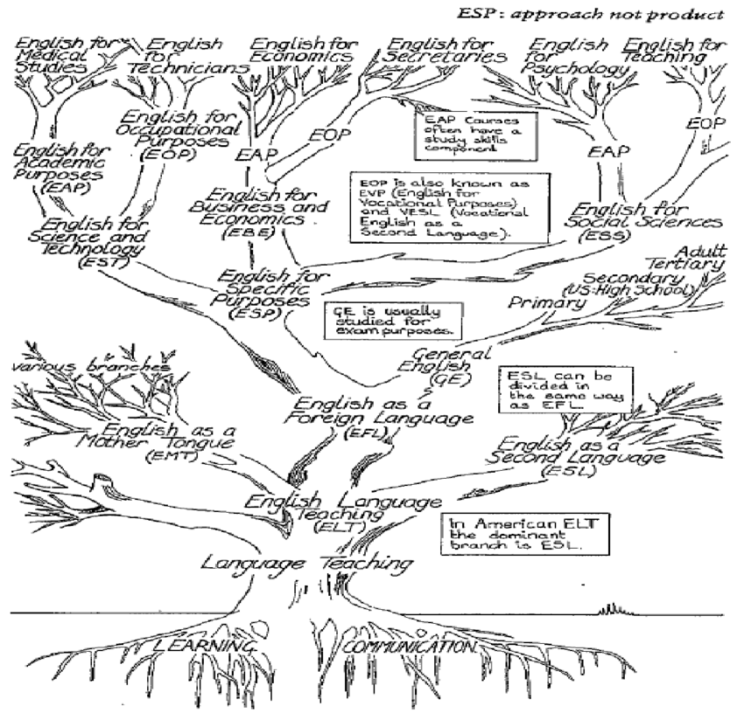

**Figure 4: ELT Tree (Hutchinson and Waters, 1987: 17)**

**3.5.3-- David Carter’s Classification of ESP**

David Carter (1983) identifies three types of ESP:

* English as a restricted language.
* English for Academic and Occupational Purposes.
* English with specific topics.

According to Carter (1983), the language used by waiters is an example of English as a restricted language. Hence, Mackay and Mountford (1978:5) posite that:

Knowing a restricted ‘language’ would not allow the speaker to communicate effectively in novel situations, or in contexts outside the vocational environment. English for Academic and Occupational purposes are respective examples of ‘English for Biological studies and English for Technicians’.

As far as English for Specific topics is concerned, Carter (1983) notes that it is only here where emphasis shifts from purpose to topic. This type of ESP is uniquely concerned with anticipated future English needs of, for example, scientists require English for postgraduate reading studies, attending conferences or working in foreign institutions.

**References**

* Allwright, J. and Allwright, R (1977). *An approach to the teaching of medical English. In English for Specific Purposes*. Ed. S. Holden. Oxford: Modern English Publications.
* Basturkmen, H. (2006). *Ideas and Options in English for Specific Purposes.* Mahwah, New Jersey: Lawrence Erlbaum Associates
* Dudley-Evans, T. and St. John, M. (1998). *Developments in English for specific purposes: A multi-disciplinary approach Cambridge*: Cambridge University Press.
* Flowerdrew, J & Peacock, M (2001). *Research Perspectives on English for Academic Purposes.* Cambridge: Cambridge University Press.
* Harmer, J. (1983). *The Practice of English Language Teaching*. New York: Longman
* Hutchinson, T. and Waters, A. (1987). *English for specific purposes. A learning centered approach.* Cambridge: Cambridge University Press.
* Johns, Ann. 2013. “The history of English for Specific Purposes research”. In Paltridge, B. & S. Starfield (eds.), The Handbook of English for Specific Purposes. Chichester, UK: Wiley-Blackwell, 5–30.
* Kennedy, C., and Bolitho, R.(1984). *English for Specific Purposes*. Macmillan: Modern English Publications.
* Mc. Donough, J (1984*). ESP in Perspective?? A Practical Guide* [M]. London and Glasgow: Collins EST.
* Munby. J (1978). *Communicative Syllabus Design*[ M]: Cambridge University Press.
* Paltridge, Brian & Sue Starfield (eds.). 2013. The Handbook of English for Specific Purposes. Chichester, UK: Wiley-Blackwell.
* Robinson, P. (1991). *ESP Today: A* Practitioner’s Guide. New York: Prentice Hall.
* Strevens.P (1980).Teaching English as an International Language: From practice to principle.Oxford:Pergamon Press.
* Yassin, A. (1999) *The Need for ESP/EAP Teacher Training in Sudanese Tertiary Institutions Post- Arabicization*. Unpublished ph. D thesis. Khartoum: Khartoum University. Sudan.