**The Iron–Carbon phase diagram**

Of all binary alloy systems, the one that is possibly the most important is that for iron and carbon. Both steels and cast irons, primary structural materials in every technologically advanced culture, are essentially iron–carbon alloys.

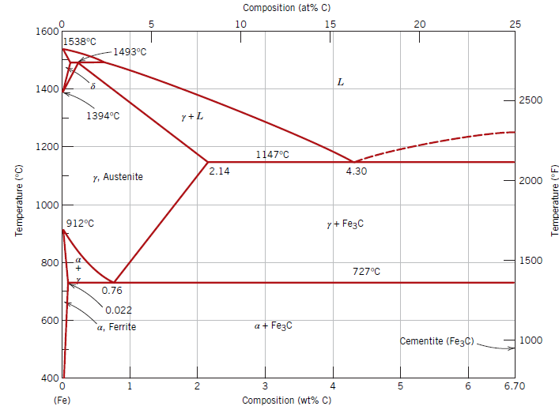

**Figure 1.** The iron–iron carbide phase diagram.

A portion of the iron–carbon phase diagram is presented in Figure 1. Pure iron, upon heating, experiences two changes in crystal structure before it melts. At room temperature, the stable form, called **ferrite,** or *α*-iron, has a Body-centered cubic (BCC) crystal structure. Ferrite experiences a polymorphic transformation to face-centered cubic (FCC) **austenite,** or *γ*-iron, at 912°C (1674°F). This austenite persists to 1394°C (2541°F), at which temperature the FCC austenite reverts back to a BCC phase known as *𝛿*-ferrite, which finally melts at 1538°C (2800°F). All these changes are apparent along the left vertical axis of the phase diagram.

The composition axis in Figure 1 extends only to 6.70 wt%[1] C (weight in terms of grams); at this concentration the intermediate compound iron carbide, or **cementite** (Fe3C), is formed, which is represented by a vertical line on the phase diagram. Thus, the iron–carbon system may be divided into two parts: an iron-rich portion, as in Figure 1, and the other (not shown) for compositions between 6.70 and 100 wt% C (pure graphite). In practice, all steels and cast irons have carbon contents less than 6.70 wt% C; therefore, we consider only the iron–iron carbide system. Figure 1 would be more appropriately labeled the Fe–Fe3C phase diagram because Fe3C is now considered to be a component.

Convention and convenience dictate that composition still be expressed in “wt% C” rather than “wt% Fe3C”; 6.70 wt% C corresponds to 100 wt% Fe3C.

Carbon is an interstitial impurity in iron and forms a solid solution with each of *α*- and *𝛿*-ferrites and also with austenite, as indicated by the *α*, *𝛿*, and *γ* single-phase fields in Figure 1. In the BCC *α*-ferrite, only small concentrations of carbon are soluble; the maximum solubility is 0.022 wt% at 727°C (1341°F). The limited solubility is explained by the shape and size of the BCC interstitial positions, which make it difficult to accommodate the carbon atoms. Even though present in relatively low concentrations, carbon significantly influences the mechanical properties of ferrite. This particular iron–carbon phase is relatively soft, may be made magnetic at temperatures below 768°C (1414°F), and has a density of 7.88g/cm3. Figure 2a is a photomicrograph of α-ferrite.

The austenite, or γ phase, of iron, when alloyed with carbon alone, is not stable below 727°C (1341°F), as indicated in Figure 1. The maximum solubility of carbon in austenite, 2.14wt%, occurs at 1147°C (2097°F). This solubility is approximately 100 times greater than the maximum for BCC ferrite because the FCC octahedral sites are larger than the BCC tetrahedral sites and, therefore, the strains imposed on the surrounding iron atoms are much lower. As the discussions that follow demonstrate, phase transformations involving austenite are very important in the heat treating of steels. In passing, it should be mentioned that austenite is nonmagnetic. Figure 2b shows a photomicrograph of this austenite phase.

The 𝛿-ferrite is virtually the same as α-ferrite, except for the range of temperatures over which each exists. Because the 𝛿-ferrite is stable only at relatively high temperatures, it is of no technological importance and is not discussed further.

Cementite (Fe3C) forms when the solubility limit of carbon in α-ferrite is exceeded below 727°C (1341°F) (for compositions within the α + Fe3C phase region). As indicated in Figure 10.28, Fe3C also coexists with the γ phase between 727°C and 1147°C (1341°F and 2097°F).

Mechanically, cementite is very hard and brittle; the strength of some steels is greatly enhanced by its presence.

Strictly speaking, cementite is only metastable; that is, it remains as a compound indefinitely at room temperature. However, if heated to between 650°C and 700°C (1200°F and 1300°F) for several years, it gradually changes or transforms into α-iron and carbon, in the form of graphite, which remains upon subsequent cooling to room temperature.

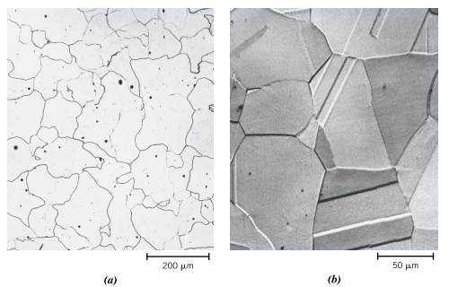

**Figure 2.** Photomicrographs of (a) α-ferrite and (b) austenite.

Thus, the phase diagram in Figure 10.28 is not a true equilibrium one because cementite is not an equilibrium compound. However, because the decomposition rate of cementite is extremely sluggish, virtually all the carbon in steel is as Fe3C instead of graphite, and the iron–iron carbide phase diagram is, for all practical purposes, valid. As will be seen in Section 13.2, addition of silicon to cast irons greatly accelerates this cementite decomposition reaction to form graphite.

1. Converting between at% and wt% (https://www.southampton.ac.uk/~pasr1/g7.htm)