**Mechanical Behavior**

1. **Metals**

For most metallic materials, elastic deformation persists only to strains of about 0.005. As the material is deformed beyond this point, the stress is no longer proportional to strain (Hooke’s law), and permanent, non-recoverable, or **plastic deformation** occurs. Figure 1 plots schematically the tensile stress–strain behavior into the plastic region for a typical metal. The transition from elastic to plastic is a gradual one for most metals; some curvature results at the onset of plastic deformation, which increases more rapidly with rising stress.

From an atomic perspective, plastic deformation corresponds to the breaking of bonds with original atom neighbors and then the reforming of bonds with new neighbors as large numbers of atoms or molecules move relative to one another; upon removal of the stress, they do not return to their original positions.

**TENSILE PROPERTIES**

**Yielding and Yield Strength**

Most structures are designed to ensure that only elastic deformation will result when a stress is applied. It is therefore desirable to know the stress level at which plastic deformation begins, or where the phenomenon of yielding occurs. For metals that experience this gradual elastic–plastic transition, the point of yielding may be determined as the initial departure from linearity of the stress–strain curve. The magnitude of the yield strength for a metal is a measure of its resistance to plastic deformation. Yield strengths range from 35 MPa (5000 psi) for a low-strength aluminum to over 1400 MPa (200,000 psi) for high-strength steels.

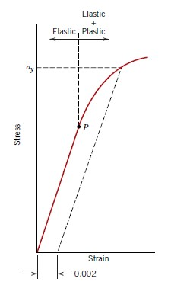

Figure 1. Typical stress–

strain behavior for a metal, showing

elastic and plastic deformations, the

proportional limit P, and the yield

strength , as determined using the

0.002 strain offset method.

**Tensile Strength**

After yielding, the stress necessary to continue plastic deformation in metals increases to a maximum, and then decreases to the eventual fracture. The tensile strength *TS* (MPa or psi) is the stress at the maximum on the engineering stress–strain curve. This corresponds to the maximum stress that can be sustained by a structure in tension; if this stress is applied and maintained, fracture will result.

Tensile strengths may vary anywhere from 50 MPa (7000 psi) for an aluminum to as high as 3000 MPa (450,000 psi) for the high-strength steels. Ordinarily, when the strength of a metal is cited for design purposes, the yield strength is used. This is because by the time a stress corresponding to the tensile strength has been applied, often a structure has experienced so much plastic deformation that it is useless. Furthermore, fracture strengths are not normally specified for engineering design purposes.

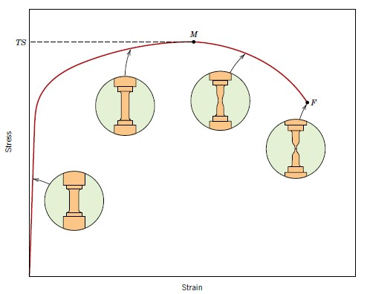

Figure 2. Typical engineering stress–strain behavior to fracture, point F. The tensile strength *TS* is indicated at point M. The circular insets represent the geometry of the deformed specimen at various points along the curve.

**Ductility**

Ductility is another important mechanical property. It is a measure of the degree of plastic deformation that has been sustained at fracture. A material that experiences very little or no plastic deformation upon fracture is termed brittle.

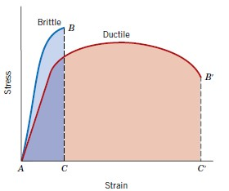

Figure 3. Schematic representations of

tensile stress–strain behavior for brittle and

ductile metals loaded to fracture.

Knowledge of the ductility of materials is important for at least two reasons. First, it indicates to a designer the degree to which a structure will deform plastically before fracture. Second, it specifies the degree of allowable deformation during fabrication operations.

We sometimes refer to relatively ductile materials as being “forgiving,” in the sense that they may experience local deformation without fracture, should there be an error in the magnitude of the design stress calculation. Brittle materials are approximately considered to be those having a fracture strain of less than about 5%.

**Resilience**

Resilience is the capacity of a material to absorb energy when it is deformed elastically and then, upon unloading, to have this energy recovered. The associated property is the modulus of resilience, , which is the strain energy per unit volume required to stress a material from an unloaded state up to the point of yielding.

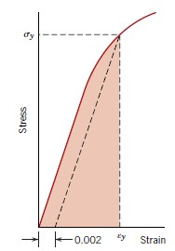

Figure 4. Schematic representation showing

how modulus of resilience (corresponding to the

shaded area) is determined from the

tensile stress–strain behavior of a material.

**Toughness**

Toughness is a mechanical term that may be used in several contexts; loosely speaking, it is a measure of the ability of a material to absorb energy up to fracture.

The units for toughness are the same as for resilience (i.e., energy per unit volume of material). For a material to be tough, it must display both strength and ductility; and often, ductile materials are tougher than brittle ones. Hence, even though the brittle material has higher yield and tensile strengths, it has a lower toughness than the ductile one, by virtue of lack of ductility.

1. **Ceramics**

Ceramic materials are somewhat limited in applicability by their mechanical properties, which in many respects are inferior to those of metals. The principal drawback is a disposition to catastrophic fracture in a brittle manner with very little energy absorption. In this section we explore the salient mechanical characteristics of these materials and how these properties are measured.

**FLEXURAL STRENGTH**

The stress–strain behavior of brittle ceramics is not usually ascertained by a tensile test, for three reasons. First, it is difficult to prepare and test specimens having the required geometry. Second, it is difficult to grip brittle materials without fracturing them. Third, ceramics fail after only about 0.1% strain, which necessitates that tensile specimens be perfectly aligned to avoid the presence of bending stresses, which are not easily calculated.

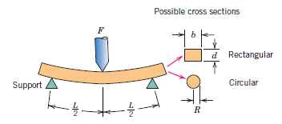Figure 5. A three-point loading scheme for measuring the stress–strain behavior and flexural strength of brittle ceramics, including expressions for computing stress for rectangular and circular cross sections.

**ELASTIC BEHAVIOR**

The elastic stress–strain behavior for ceramic materials using these flexure tests is similar to the tensile test results for metals: a linear relationship exists between stress and strain. Figure 6 compares the stress–strain behavior to fracture for aluminum oxide (alumina) and glass. Again, the slope in the elastic region is the modulus of elasticity; the moduli of elasticity for ceramic materials are slightly higher than for metals.

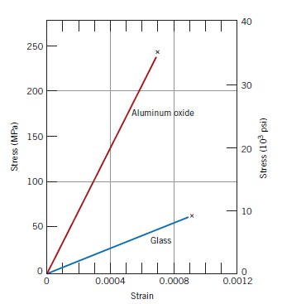

Figure 6. Typical stress–strain behavior to fracture for aluminum oxide and glass.

1. **Polymers**

**STRESS–STRAIN BEHAVIOR**

The mechanical properties of polymers are specified with many of the same parameters that are used for metals, that is, modulus of elasticity and yield and tensile strengths. For many polymeric materials, the simple stress–strain test is used to characterize some of these mechanical parameters. The mechanical characteristics of polymers, for the most part, are highly sensitive to the rate of deformation (strain rate), the temperature, and the chemical nature of the environment (the presence of water, oxygen, organic solvents, etc.). Some modifications of the testing techniques and specimen configurations used for metals are necessary with polymers, especially for highly elastic materials, such as rubbers.

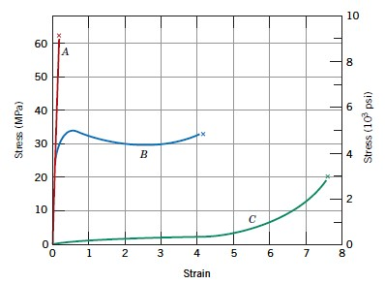

Figure 7. The stress–strain behavior for brittle (curve A), plastic (curve B), and highly elastic (elastomeric) (curve C) polymers.

Polymers are, in many respects, mechanically dissimilar to metals and ceramic materials. For example, the modulus for highly elastic polymeric materials may be as low as 7 MPa (103 psi), but it may run as high as 4 GPa (0.6 × 106 psi) for some of the very stiff polymers; modulus values for metals are much larger. Maximum tensile strengths for polymers are about 100 MPa (15,000 psi), whereas for some metal alloys they are 4100 MPa (600,000 psi). Furthermore, whereas metals rarely elongate plastically to more than 100%, some highly elastic polymers may experience elongations to greater than 1000%.

In addition, the mechanical characteristics of polymers are much more sensitive to temperature changes within the vicinity of room temperature. Consider the stress–strain behavior for polymethyl methacrylate (Plexiglas) at several temperatures between 4°C and 60°C (40°F and 140°F). Increasing the temperature produces (1) a decrease in elastic modulus, (2) a reduction in tensile strength, and (3) an enhancement of ductility at 4°C (40°F) the material is totally brittle, whereas there is considerable plastic deformation at both 50°C and 60°C (122°F and 140°F). The influence of strain rate on the mechanical behavior may also be important. In general, decreasing the rate of deformation has the same influence on the stress–strain characteristics as increasing the temperature: that is, the material becomes softer and more ductile.

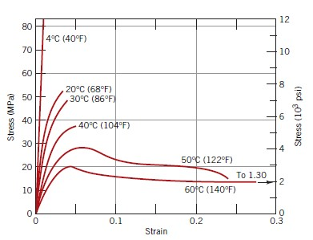

Figure 8. The influence of temperature on the stress–strain characteristics of polymethyl methacrylate.