|  |
| --- |
| **Ahmed Zabana University Level : Master 1**  **Faculty of Letters and Foreign Languages Module : Applied Linguistics**  **English Department Teacher in Charge : Chibani Safia**  **First Semester Academic Year : 2021-2022**  **Date : 24/10/2021** |

**Lecture Title:** An Introductory Lecture about Applied Linguistics

**Lecture Outline:**

-Definition

-Main Characteristics

-Historical Background

-Relevance and Scope of Applied Linguistics

|  |
| --- |
| **Objective:** By the end of this lecture, students will get a better understanding of what is meant by Applied Linguistics. In addition, they will be introduced to its fundamentals. |

**1. Introduction**

Like most concepts, Applied Linguistics lends itself to no one definition. In fact, several definitions in the literature can be found, and each of them provides a more or less plausible explanation of it. However, it should be noted that the likeliest explanation cannot be achieved without providing an overview on Linguistics.

**What is Linguistics?**

Linguistics is the scientific study of language. It is divided into six core branches all grouped under the banner of **Microlinguistics**. They investigate language in terms of pronunciation, structure, use, and vocabulary.

1. **Phonetics:** the study of speech sounds and how they are articulated, transmitted, and received.
2. **Phonology:** the branch of linguistics which studies the sound systems of languages. While phonetics is chiefly concerned with the physical nature of speech sounds, phonology deals with the ways in which sounds behave in languages.
3. **Morphology:** the branch of linguistics which studies word structure. It is the study of morphemes, their different forms, and the ways they combine in word formation.
4. **Syntax:** the branch of linguistics studying sentence structure. Syntax is concerned with the ways in which words combine to form sentences and the rules governing the formation of sentences.
5. **Semantics:** the branch of linguistics interested in meaning. Semantics studies how meaning is structured, and investigates the relation between linguistic. expressions or words of a language and what they refer to in the real world (persons, things, events, etc.).
6. **Pragmatics:** the study of language use in communication, particularly the relationships between sentences and the contexts in which they are used.[1]

In addition to the six core branches of linguistics, eight fields of study can also be identified. They all explore language in relation to something in the real world. As it is the case with the following **Macrolinguistics** areas of investigation:

1. **Sociolinguistics:** the study of language in relation to social factors such as social class, type and level of education, ethnic origin, etc.
2. **Psycholinguistics:** the study of (a) the mental processes that a person uses in producing and understanding language, and (b) how humans learn language. Psycholinguistics includes the study of speech perception in addition to the role of memory, and other factors (social, psychological, etc.) in language use.
3. **Neurolinguistics:** the study of the brain functions in language learning/use. Neurolinguistics includes research into how the structure of the brain influences language learning, how and in which parts of the brain language is stored, and how brain damage affects the ability to use language.
4. **Discourse Analysis or Text Linguistics:** the study of how sentences in spoken and written language form larger meaningful units such as paragraphs, conversations, interviews, etc.
5. **Forensic Linguistics:** a branch that investigates issues of language in relation to the law. Issues of concern include forensic identification (speaker identification in legal cases through handwriting analysis or speech analysis); interpretation for the police and courts; the semantics of legal terminology (e.g. the legal meanings of murder, manslaughter, homicide); the discourse of police interrogations and legal proceedings; etc.
6. **Computational Linguistics:** the scientific study of language from a computational perspective. Computational linguists are interested in providing computational models of natural language processing (both production and comprehension) and various kinds of linguistic phenomena. The work of computational linguists is incorporated into such practical applications as speech recognition systems, speech synthesis, automated voice response systems, web search engines, text editors, and language instruction materials.
7. **Anthropological Linguistics:** a branch of linguistics which studies the relationship between language and culture in a community, e.g., its traditions, beliefs, and family structure. Sometimes anthropological linguistics investigations interfere with sociolinguistics and the ethnography of communication.
8. **Cognitive Linguistics:** an approach to linguistics which stresses the interaction between language and cognition focusing on language as an instrument for organizing, processing, and conveying information.

Thus, Linguistics studies language in all of its aspects providing a methodology to investigate its internal structure and how it evolves over time and between different societies. Moreover, it explores the way language is learnt and used for human communication. Interestingly, these approaches to linguistic study are more relevant to the concerns of Applied Linguistics.

**2. Selected Definitions of Applied Linguistics**

|  |  |
| --- | --- |
| **First Definition**  **Schmitt and Celce-Murcia (2002)** | Applied Linguistics uses what we know about a) language b) how it is learned c) and how it is used in order to achieve some purpose or solve some problems in the real world. |
| **Second Definition**  **Christopher Brumfit (1977)** | Applied Linguistics is the theoritical and empirical investigation of real world problems in which language is the central issue. |
| **Third Definition**  **William Grabe (2000)** | The focus of Applied Linguistics is on trying to resolve language based problems that people encounter in the real world whether they be learners, teachers, supervisors,…or a whole range of clients. |
| **Fourth Definition**  **(Crystal 1985)** | Applied Linguistics is a brand of linguistics where the primary concern is the application of linguistic theories, methods and findings to the elucidation of language problems which has arisen in other areas of experience |
| **Fifth Definition**  **Stevens (1992)** | It is a multidisciplinary approach to the solution of language-related problems. |
| **Sixth Definition**  **Davis and Elder (2006)** | Applied Linguistics, in our view, a coherent activity that theorises through speculative and empirical investigations real-world problems in which language is a central issue. |

We can deduce from the array of provided definitions that Applied Linguistics helps solve problems that relate to the application of language in the real world. Four parameters summarize the main issues dealt with in the field of Applied Linguistics:

* + How language is used? language use
  + How language is learnt? language acquisition
  + How language is taught? language teaching
  + How to determine what people know? language assessment

Related sub-issues :

* + - How can we teach language better?
    - What type of individual differences do we have in language learning?
    - What are the related problems associated with language disorders? And how can these be prevented?
    - What are the social influences that affect language learning?
    - How can we write a valid language examination?
    - How can technology be used to contribute to the effectiveness of language teaching and learning?
    - How can we best advise Ministry of Education officials, curriculum planners and other stake holders in the Education Ministry on the content of a language curriculum for various groups of people and communities?
    - What kind of language should be the language of instruction in schools?
    - How can we have valid language tests?

**3. The Main Charasteristics of Applied Linguistics:**

|  |  |
| --- | --- |
| **First Charasteristic** | It is **a theory-based discipline** in the sense that it does not only consume knowledge from its main source namely linguistics, but it also generates knowldge. The body of theoritical knowledge it comes up with is used to inform teaching practicioners about how to teach a second or foreign language with appropriate modifications to fit their immediate contexts. Hence, It is consuming and productive at the same time. |
| **Second Charasteristic** | It is **a problem-oriented discipline**. It is mainly concerned with language-related problems. |
| **Third Charasteristic** | It is **an interdisciplinary and multidisciplinary** field of study. It is said that all disciplines come together or interact in Applied Linguistics. Some of the fields related to applied linguistics are : education, psychology, communication research, anthropology and sociology. |
| **Fourth Characteristic** | While Linguistics centres on the theoritical aspects of language, Applied linguistics scrutinizes the practical aspects. |

**4. The Historical Background of Applied Linguistics**

The reason why people view Applied Linguistics in rather different ways is because it has its origin in different places in the world. The studies of Applied Linguistics were first seen, most notably, in three countries-the United States of America, the United Kingdom, and Australia (Davies and Elder, 2004). Nevertheless, the term Applied Linguistics which refers to the application of linguistic knowledge to the study and improvement of language teaching and learning, language planning, management of language defects, communication between groups, lexicography,, translation etc… owes its origin to US language teaching programmes during and after the second world war.

Three associations have been set up in various parts of the world with an avid interest in Applied Linguistics:

**1.The American Association for Applied Linguistics (AAAL) :** is a professional society whose members use a wide variety of theoretical frameworks and methodological approaches to address a broad range of language of language-related issues that affect individuals and society. The mission of AAAL is to facilitate the advancement and dissemination of knowledge and understanding regarding these language-related issues in order to improve the lives of individuals and conditions in society.

**2.** **The British Association for Applied Linguistics (BAAL):** is a professional association based in the UK, which provides a forum for people interested in language and the application of linguistics.

**3.** **The Applied Linguistics Association of Australia (ALAA):** is the national organization for Applied Linguistics in Australia. ALAA aims to provide leadership in the field and supports the development of teaching among the ethnic, political social and bureaucratic and class groupings. It also draws on knowledge that is far beyond linguistics to solve language- related problems where necessary.

According to Grabe, national associations of Applied Linguistics came together in 1964 to form the Association Internationale de la Linguistique Appliquée (AILA). This association holds a congress every four years with publication proceedings.

**5. The Relevance and Scope of Applied Linguistics**

Language is at the heart of human life, without it, many of our most important activities are inconceivable. Since language is implicated in so much of our daily life, there is clearly a large and open-ended number of quite disparate activities to which Applied Linguistics is relevant.

**1. Language and Education:**

**a. First and Second Language Acquisition:** Applied Linguistics takes interests into first and second language acquisition and explores how a child and an L2 learner acquire the language.

1. **Clinical Linguistics:** is the study and treatment of speech and communication impairments, whether hereditary, developmental, or acquired (through injury, stroke, illness, or age)
2. **Language Testing:** is the assessment and evaluation of language achievement and proficiency, both in first and addtional languages, and for both general and specific purposes.

**2. Language, Work and Law:**

**a. Workplace Communication:** is the study of how language is used in the workplace, and how it contributes to the nature and power relations of different types of work.

**b. Language Planning**: is the making of decisions, often supported by legislation about the official status of lagauges and their institutional use including their use in education.

**c. Forensic Linguistics:** is the deployment of linguistic evidence in criminal and other legal investigations, for example, to establish the authorship of a document, or a profile of a speaker from a tape-recording.

**3. Language, Information and Effect:**

**a. Literary Stylistics:** is the study of the relationship between linguistic choices and effects on literature.

**b. Critical Discourse Analysis:** is the study of the relationship between linguistic choices and effects in persuasive uses of language.

**c. Translation and Interpretation:** is the formulation of principles underlying the perceived equivalence between a stretch of language and its translation, and the practices of translating written texts and interpreting spoken language.

**Ahmed Zabana University Level : Master 1**

**Faculty of Letters and Foreign Languages Module : Applied Linguistics**

**English Department Teacher in Charge : Chibani Safia**

**First Semester Academic Year : 2021-2022**

**Date : 02/01/2022**

**Lecture Title:** First and Second Language Acquisition Theories

**Lecture Outline:**

**Introduction**

**Behaviourism**

**Innativism**

**Constructivism**

**Humanism**

**Socioconstructivism**

**Objective:** By the end of this lecture, students will get a general overview of first and second language acquisition theories and see how these latter can inform our teaching.

**Introduction**

Language acquisition investigates the process through which humans acquire language. It should be noted that first language acquisition points to native language acquisition whereas second language acquisition addresses both adults’ and children’s acquisition of some additional languages other than the mother tongue. The evolution of language learning theories could be compared to a pendulum oscillating between Skinner’s Environmentalism, Piaget’s Constructivism and Chomsky’s Innativism. Indeed, most studies in the field have been devoted to prove whether cognitive process and structure was influenced by environmental input or some innate, predetermined mechanism. Noam Chomsky and Lennberg, the leading figures of Innativism, were first to reckon that native language acquisition requires some inborn language-specific competencies so as to take place. Meanwhile, some other linguists such as Catherine Snow, Elizabeth Bates and Brian Macwhinney posited that language acquisition results from a direct contact with the surrounding community and common cognitive capacities. In spite of this apparent controversy, basic theories to language acquisition cannot be set apart as they complement each other.

**Behaviorism**

The tenets of this perspective to language acquisition is based on behavioral psychology which advances that human learning approximates that of animal learning in the process of habit formation. According to Wilga Rivers (1968,73) : the behaviorist theory of stimulus-response learning, particularly as developed in the operant conditioning model of Skinner, considers all learning to be the establishment of habits as a result of reinforcement and reward.’’This model of language learning, lays emphasis on positive reinforcement and rewards. Language Tasks are broken down into small sequential steps wherein the learner acquires some particular language behavior through imitation, reinforcement and rewarding. Thus, language development is a matter of conditioning via practice, imitation, reinforcement and habituation. However, this theory has its own limitations as it suggests that language is learned only by imitation. It takes the idea that a child is a tabula rasa (a clean slate) denying the existence of any inborn capacity that might contribute to the acquisition of a language. In fact, further research has revealed that no evidence of innovation was to be found in the process of utterance imitation. The amount of imitation might differ from one child to another as a result children learn at different rates. Another counterargument about behaviorism is that it does not clarify the extent to which social context impacts language acquisition. In spite of its limitations, this view to language learning still has an influence on the way language is taught. Its tenets are applied in language laboratories where learners get a lot of repetition, drilling and substitution activities.

**Innatist Cognitive Approaches**

For fifty years, Noam Chomsky and Eric Lenneberg have hypothesized that children are endowed with some inborn, language-specific device that facilitates language acquisition. Chomsky qualifies all languages as innate sharing the same universal principles. He hypothesizes that humans’ biological donation includes a Universal Grammar, which is an innate linguistic knowledge consisting of a set of principles underlying all languages. Furthermore, he suggests that children develop their mother tongue in the same way as other biological functions such as walking. Interestingly, he admits that the human brain is equipped with some language acquisition device which contributes to its development. Accordingly, Lenneberg reckons that there is a time window or some restricted period wherein language acquisition occurs. The Critical Period Hypothesis advances that humans have some biological devices mainly associated with language acquisition and that could only be accessed during puberty. This explains why adult learners rely on the general learning mechanisms since they have already gotten past the stage wherein they can employ the biological mechanisms intended for language acquisition.

**Constructivism**

For constructivists, humans are involved throughout their whole lives in constructing their own knowledge, and they do it in their own unique way. For instance, if a teacher asks his students at the end of a lesson about what they have learnt, their answers may vary. This might be due to the fact that they have constructed meaning in their own particular individual way. It is worth noting that the work of Piaget was particularly influential in the development of constructivist ideas. Such ideas have important implications for language teaching. Bruner who is another important figure in constructivism argues that learners need to know how to learn and develop their cognitive capacities by being absorbed in challenging and meaningful problems. So they need to make guesses, speculate, use intuition, take risks, have curiosity, but they also need to be confident in their ability to solve problems. An extension of this idea is that we are continually creating and testing hypotheses, refuting and validating some in the process. Teachers following this constructivist line of thought might start a by eliciting personal or emotional responses from learners and this might be organized in a visual way with opportunities to create new knowledge with the foundation of what they already know.

**Humanism/ Humanistic Approaches**

Humanism emphasizes on considering the whole person when learning. It takes the whole individual into account. Such theory puts forward that humans’ individuality, their feelings and emotions have a direct impact on learners’ learning ability. Maslow, one of its key figures, has formed a hierarchy, where he suggests that it is difficult to fulfill the higher needs if the lower ones are not met. The pyramid below represents all of those needs.

[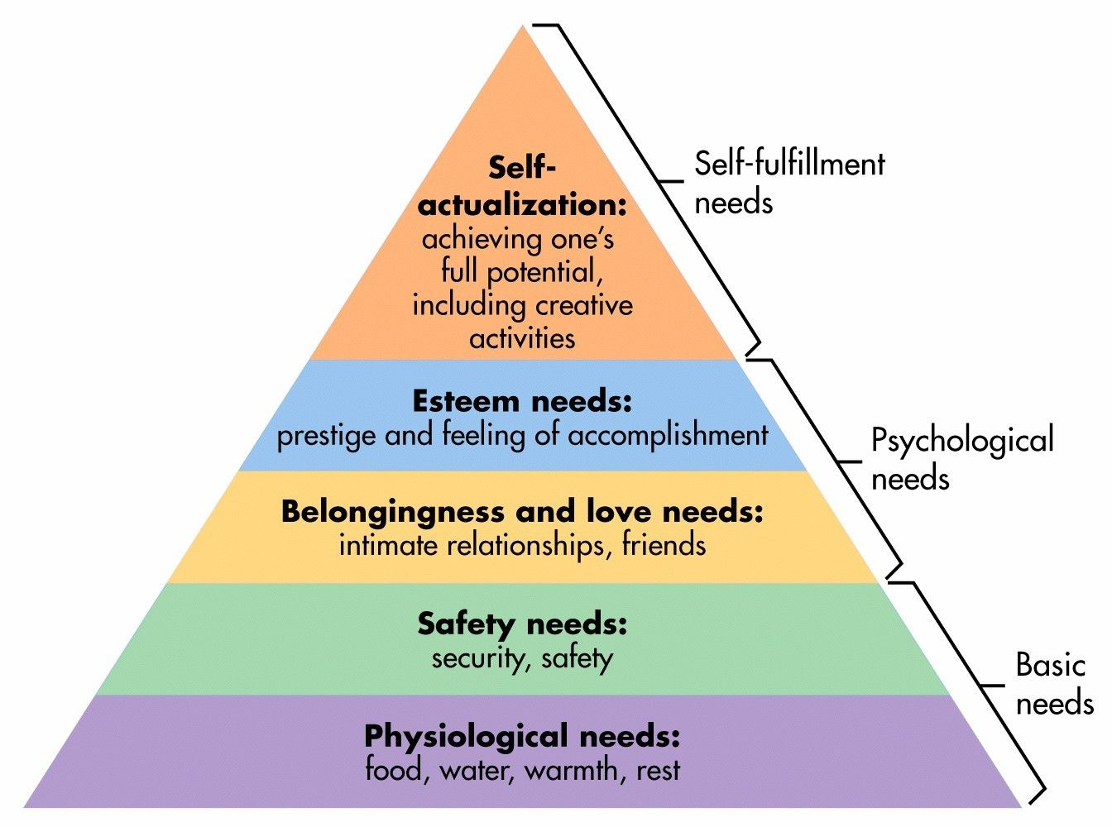](https://www.google.com/url?sa=i&url=https://www.simplypsychology.org/maslow.html&psig=AOvVaw29mZhEGKt475_Jf70g7qej&ust=1609787226752000&source=images&cd=vfe&ved=0CAIQjRxqFwoTCIjF5vO6gO4CFQAAAAAdAAAAABAI)

Students need a basic strong psychological foundation to learn in addition to the survival needs. So teachers must take this into account and provide a safe, happy and productive environment for their students. Thus, one of the main characteristics of this approach is that it goes beyond the cognitive factors.

**Sociocultural Perspectives**

This perspective does not separate the individual from the context in which they are learning. It views learning as a social process where there is a double direction-the context affects the individual, and the individual influences the context. To put this in other words, there is an interface between the context and individual. For example, the whole dynamic of a classroom might be impacted by the absence or presence of some dominant student. Vigotsky, one of the most influential psychologists in the area, came up with the idea that learning happens when the learner is faced with something that is a little bit beyond their current level of mastery. Teachers are a lot above the level of the learners and can use scaffolding which refers to a variety of instructional techniques used to move students progressively toward stronger understanding and, ultimately, greater independence in the learning process, to help the learners move to the next level. It should not go unnoticed that the space between what the student can at the moment and what they are able to do with some help is usually referred to as the zone of proximal development. Therefore, in the sociocultural perspective, knowledge is socially constructed through interaction and negotiation of the ideas of others (Chen,2014)**.**

1. All of the above definitions have been adapted from Task (2007) and Richards and Schmidt (2010).