## Lesson 3 Unit Plan Model (English for Hotel Industry)

## 1-Lesson Description

## The present lesson gives an overview of hotel businesses to students who learn from different kinds of exercises covering all 4 skills of English. The emphases of the unit are on vocabulary and expressions about hotel staff and their duties. Students have also opportunities to practice listening, speaking, reading, and writing about words and expressions essential for communication with people associated in hotel businesses and in everyday language.

## 2- Lesson Objectives

## The main objective of the unit plan model is to enable students to get the idea of how to make conversations using specific grammar form along with other common forms of making sentences. Consequently, they would to be able to communicate well with any foreign staff or guests they associate with in the future.

## 3- Lesson Content

## Unit Plan Course Syllabus

**UNIT 1**

**HOTEL STAFF AND THEIR DUTIES CONTENTS**

**Hotel Staff and Their Duties**

* 1. Listening
  2. Speaking
  3. Vocabulary
  4. Grammar

Present Simple Tense

* + - S. + is/am/are + in charge of + department
    - S. + is/am/are + responsible for + V.ing + O.

- S. + V. 1 + O.

* 1. Reading
  2. Writing
  3. Exercises

## OBJECTIVES

By the end of this unit, students should be able to:

1. Identify key vocabulary and expressions needed while talking about hotel staff and their duties.
2. Use correct forms of expressions needed in each context.
3. Fill in the blanks with correct words and expressions.
4. practice all four skills of English
5. Do exercises for the lesson

## TEACHING AND LEARNING PROCESS

Students participate in the following activities:

1. Work in groups listening and practicing each dialog.
2. Work in pairs practicing each exchange and role-play to class.
3. Do exercises using appropriate vocabulary and expressions.

## TEACHING MATERIALS

Students learn through the following teaching aids.

1. Instructional material
2. PowerPoint presentation
3. Assignments
4. Worksheets

## EVALUATION

Students will be evaluated through the following activities:

1. Attendance and participation in class activities.
2. The result of exercises and assignments they do.

## REFERENCES

Adamson, Donald. **International Hotel English.** Prentice Hall International (UK) Ltd., 1989.

Dangrojana, Pricha. **Hotel Management and Operations.** United Production Ltd. 1987.

Harding, Keith&Handerson, Paul. High Season. Oxford University Press., 1998.

Kean, Leila. **International Restaurant English**. Prentice Hall International (UK) Ltd., 1990.

Utawanit, Kanitta. **Communicative English for Hotel Personnel**. Thammasat University Press., 1998.

[https://int.search.myway.com/search/AJimage.jhtml?n=783a866d&p2=%](https://int.search.myway.com/search/AJimage.jhtml?n=783a866d&p2=%5EY6%5Echr999%5ETTAB02%5E&pg) [5EY6%5Echr999%5ETTAB02%5E&pg](https://int.search.myway.com/search/AJimage.jhtml?n=783a866d&p2=%5EY6%5Echr999%5ETTAB02%5E&pg)

[https://www.shutterstock.com/th/image-photo/female-receptionist-giving-](https://www.shutterstock.com/th/image-photo/female-receptionist-giving-room-key-couple-94781533?src=cBE2QUbuhxVdDYtfxG_RRA-4-18) [room-key-couple-94781533?src=cBE2QUbuhxVdDYtfxG_RRA-4-18](https://www.shutterstock.com/th/image-photo/female-receptionist-giving-room-key-couple-94781533?src=cBE2QUbuhxVdDYtfxG_RRA-4-18)

# UNIT 1

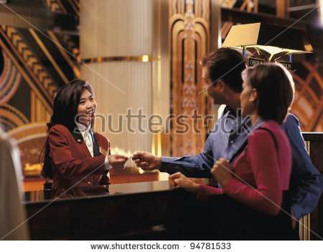

**HOTEL STAFF AND THEIR DUTIES**

**LISTENING**

1. **Robert Huge, the General Manager of the Central Hotel is conversing with Jane Blake, the new receptionist. Listen to the dialog.**

**Tape script 1.1**

[https://www.shutterstock.com/th/image-photo/female-receptionist-giving-room-key-](https://www.shutterstock.com/th/image-photo/female-receptionist-giving-room-key-couple-94781533?src=cBE2QUbuhxVdDYtfxG_RRA-4-18) [couple-94781533?src=cBE2QUbuhxVdDYtfxG_RRA-4-18](https://www.shutterstock.com/th/image-photo/female-receptionist-giving-room-key-couple-94781533?src=cBE2QUbuhxVdDYtfxG_RRA-4-18)

## At the Front Office

Robert: Hi, I’m Robert Huge. I’m the General Manager of this hotel.

Jane: Good morning, Mr. Huge. My name’s Jane Blake, the new receptionist. This is my first day here. Nice to meet you, sir.

Robert: Nice to meet you, too, Ms. Blake, and welcome to our Hotel.

By the way, have you been informed about your job as a receptionist here?

Jane: Yes, sir. I’m in charge of this front desk and I’m responsible for welcoming guests, and dealing with them when they check in and check out. Oh, by the way you can call me by my first name.

Robert: OK, Jane. Besides welcoming guests, and taking care of their checking in and out, your duties include receiving reservations from guests too.

Jane: All right, Mr. Huge. Thank you for your advice. Robert: You’re welcome. See you later.

## Listen again and answer the questions.

* 1. Who is the new staff member of the hotel?
  2. What does a receptionist/ reception clerk do?
  3. Who is the boss?

## Listen to the dialog again and complete the following sentences. Tape script 1.2

* 1. I’m the General [1] of this hotel.
  2. This is my first day here. Nice to [2] you, sir.
  3. Nice to meet you, too, Ms. Blake, and [3] to our Hotel.
  4. By the way, have you been informed about your job as a [4] here?
  5. I’m in [5] of this front desk and ….
  6. I’m responsible for welcoming [6] , and dealing with them when they [7] and check out.
  7. OK, Jane. Besides …. your duties [8] receiving reservations from guests too.
  8. All right, Mr. Huge. Thank you for your [9] .
  9. You’re welcome. [10] later.

## Listen to the hotel staff members talking about their jobs and their duties. Then complete the chart.

**Tape script 1.3**

|  |  |  |  |
| --- | --- | --- | --- |
| **Name** | | **Job/Position** | **Duty** |
| 1 | Robert Huge | General Manager | supervising all staff members |
| 2 | Jane Blake | receptionist | ………………………………… |
| 3 | Tim Brown | …………………… | …………………… making food for guests |
| 4 | Mary Kane | cashier | in charge of …………………… |
| 5 | Somchai Jaidee | …………………… | …………………………… with their luggage and ………….. |
| 6 | Rebecca Kim | chambermaid/ room maid | …………………………..that guests’ rooms ……………….. |

|  |  |  |  |
| --- | --- | --- | --- |
|  |  |  | and room fittings are in order |
| 7 | Jack Wilson | lift attendant | ………………………………… guests in the elevator/ lift |

**SPEAKING**

1. **Work in groups of 4. Listen to what each of the staff talks again and then take turn to practice saying each job and the duty above.**
2. **Work in pairs practicing the following model dialog.**

Jill: What do you do?/ What is your job? John: I’m a personnel manager.

Jill: What is your duty/ responsibility?

What does a personnel manager do?

John: I recruit new staff./ I’m responsible for recruiting new staff.

## Work in pairs. Make your own dialog and role play a job and the duty. Then take turn to practice it.

A:

B:

## Work in pairs and practice a dialog by using the information about the staff in Listening 4. Use the following dialog as your model.

A: What does *Robert* do?/ What is *Robert’s* job? B: He’s a personnel manager.

A: What is his duty/ responsibility?

B: He recruits new staff./ He’s responsible for recruiting new staff.

**VOCABULARY**

1. **Match each job with a suitable duty.**

|  |  |
| --- | --- |
| **jobs** | **duties** |
| a waiter/a waitress | gives and takes room keys from guests |
| a bartender | in charge of a large group of guests eating at the restaurant |
| a catering manager | responsible for greeting guests and helping them with their luggage and transport |
| a banqueting manager | makes drinks for guests |
| a key clerk/a room clerk | deals with all the incoming and outgoing calls |
| a switchboard operator | takes orders and serves food to guests |
| a doorman | in charge of restaurant services; serving food and beverages |

1. **Work in groups of four. Write out at least 15 hotel jobs that you know with the meanings in Thai to make sure that you know the words.**



|  |  |  |
| --- | --- | --- |
| **No.** | **words** | **meanings in Thai** |
| 1. | waiter | **บรกิ รชาย** |
| 2. | maintenance engineer | …….. |
| 3. | housekeeper | …….. |
| 4. | accountant | …….. |
| 5. |  |  |
| 6. |  |  |
| 7. |  |  |
| 8. |  |  |
| 9. |  |  |
| 10. |  |  |
| 11. |  |  |
| 12. |  |  |
| 13. |  |  |
| 14. |  |  |
| 15. |  |  |

**GRAMMAR**

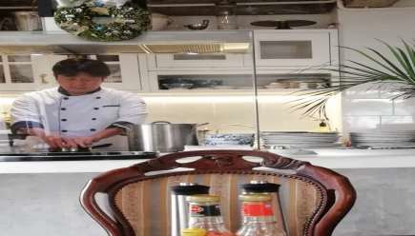

When talking about jobs and duties, we use simple present tense since it is regular and always true. We usually use the present form of verb to be with ‘responsible for’ and ‘in charge of’ plus a gerund phrase and a noun phrase to describe a duty of each job.

|  |  |  |  |
| --- | --- | --- | --- |
| I | am | responsible for | v.ing |
| You/ We/ They | are |
| He/ She/ It | is | in charge of | noun |

Picture 1.3: At a hotel in Ubonratchatani, Thailand Source: Ratana Watawatana, 2017

I am a chef.

I am **responsible for** *cooking food* for guests*.* I am **in charge of** the hotel kitchen matters.

They are chambermaids.

They are **responsible for** *keeping the guests’ rooms clean.*

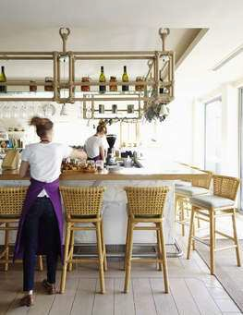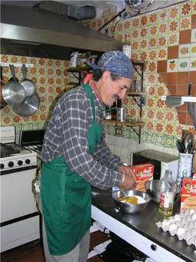

They are **in charge of** the *guests’ rooms.*

Sue is a laundry maid.

She is **responsible for** *doing the laundry for guests.*

She is **in charge of** the laundry service.

## 1. Look at the pictures. Work in groups of 4 and help one another make sentences about hotel staff and their duties. Use the grammar form above.

1 2

1.

2.

3 4

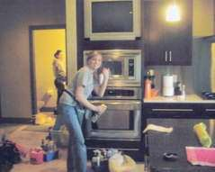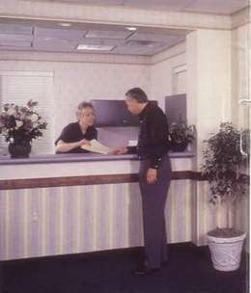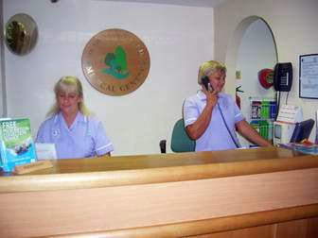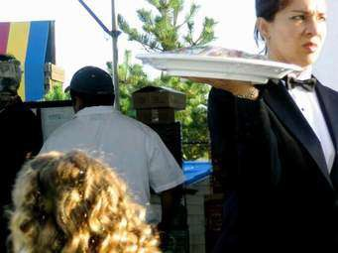

5 6

**Pictures**: 1.3-1.9: Hotel staff of different jobs

**Sorce:** [https://int.search.myway.com/search/AJimage.jhtml?n=783a866d&p2=%5E](https://int.search.myway.com/search/AJimage.jhtml?n=783a866d&p2=%5EY6%5Echr999%5ETTAB02%5E&pg) [Y6%5Echr999%5ETTAB02%5E&pg](https://int.search.myway.com/search/AJimage.jhtml?n=783a866d&p2=%5EY6%5Echr999%5ETTAB02%5E&pg)

3.

4.

_



5.

6.

**READING**

1. **Work in groups of 5. Read the following magazine extracts and decide which job you think is the most interesting. Discuss your reasons with the group members.**

**People in Hotel Services**

**M**ary Lue works as a receptionist in the Novotel Hotel in Bangkok. She was born in Hong Kong and is very happy here. She likes this job because she is interested in meeting different people every day.

She welcomes guests and helps them with their check in and check out at the hotel. She likes getting to know them and talking to them. The best thing about the job is that she can learn more about people and their different cultures.

**P**aul White is a chef in the Narai Hotel in Krabi. He was born in New Zealand and works in the South of Thailand. He loves swimming and sunbathing on the beach. However, he is very busy preparing materials and ingredients for his recipe. He enjoys making his guests happy with his specialties each time the dish is served.

**Discussion:**………………………………………………………………



…………………………………………………………………………..

## Read the texts again and imagine the job you want to do at each hotel. Discuss in groups and present the group conclusion to the rest of the class.

1. **Then answer the questions about the texts.**
   1. Where is Mary Lue from?
   2. What about Paul White?
   3. What does Mary like best about her job?
   4. What do you think Paul does in his free time?
   5. Do you think it is easy to make a recipe? Why?

**WRITING**



1. **Work in pairs writing sentences about 5 different hotel jobs and their duties using appropriate grammar forms. Use the words from your answer of 15 jobs in the vocabulary part (Vocabulary 2).**

1.

2.

3.

4.

5.

## Write sentences about 3 of your friends and 2 of your family members. Then present to class about what he/she does for living and what his/ her responsibilities are. You can add more details about the people you mention.

**Example:** My friend, James, is **a teacher**. He works at a high school. He **is responsible for** teaching English to Mattayomsuksa 2 students.

1.

2.



3.

4.

5.